**An Industry Oriented Mini Project Report**

**on**

**Detection Of Glaucoma From Fundus Images**

**Of The Eye**

*Submitted to*

***Guru Nanak Institute of Technology (Autonomous*)**

in partial fulfilment of the requirements for the award of the degree of

**BACHELOR OF TECHNOLOGY**

in

**COMPUTER SCIENCE AND ENGINEERING**

**(ARTIFICIAL INTELLIGENCE AND MACHINE LEARNING)**

By

**ANURADHA NAYAK 21831A6605**

**GANDE LOKESH 21831A6625**

**GUDLA HEMANTH 21831A6626**

Under the Esteemed Guidance of

**Mr. M. PRABHU PANDIYAN**

 Assistant Professor, CSE (AI & ML)

**DEPARTMENT OF COMPUTER SCIENCE AND ENGINEERING**

**(AIML)**

**GURU NANAK INSTITUTE OF TECHNOLOGY**

**(Affiliated to JNTUH-Hyderabad)** **Ranga Reddy District -501506**

**2024-2025**

**GURU NANAK INSTITUTE OF TECHNOLOGY**

**(Autonomous)**

**Ranga Reddy District -501506**

**CERTIFICATE**

This is to certify that the project entitled “**Detection of Glaucoma from Fundus Images of the Eye**” is being presented with report by **GANDE LOKESH (21831A6625), ANURADHA NAYAK (21831A6605), GUDLA HEMANTH (21831A6626)** in partial fulfilment for the award of **Degree** **of Bachelor of Technology in Computer Science and Engineering (Artificial Intelligence & Machine Learning)**, to **Guru Nanak Institute of Technology (Autonomous).**

**Mr. M. PRABHU PANDIYAN Mr. E. VINAY KUMAR**

**Internal Project Guide Project Coordinator**

**Dr . MAHESH LOKHANDE EXTERNAL EXAMINER**

**Head of Department**

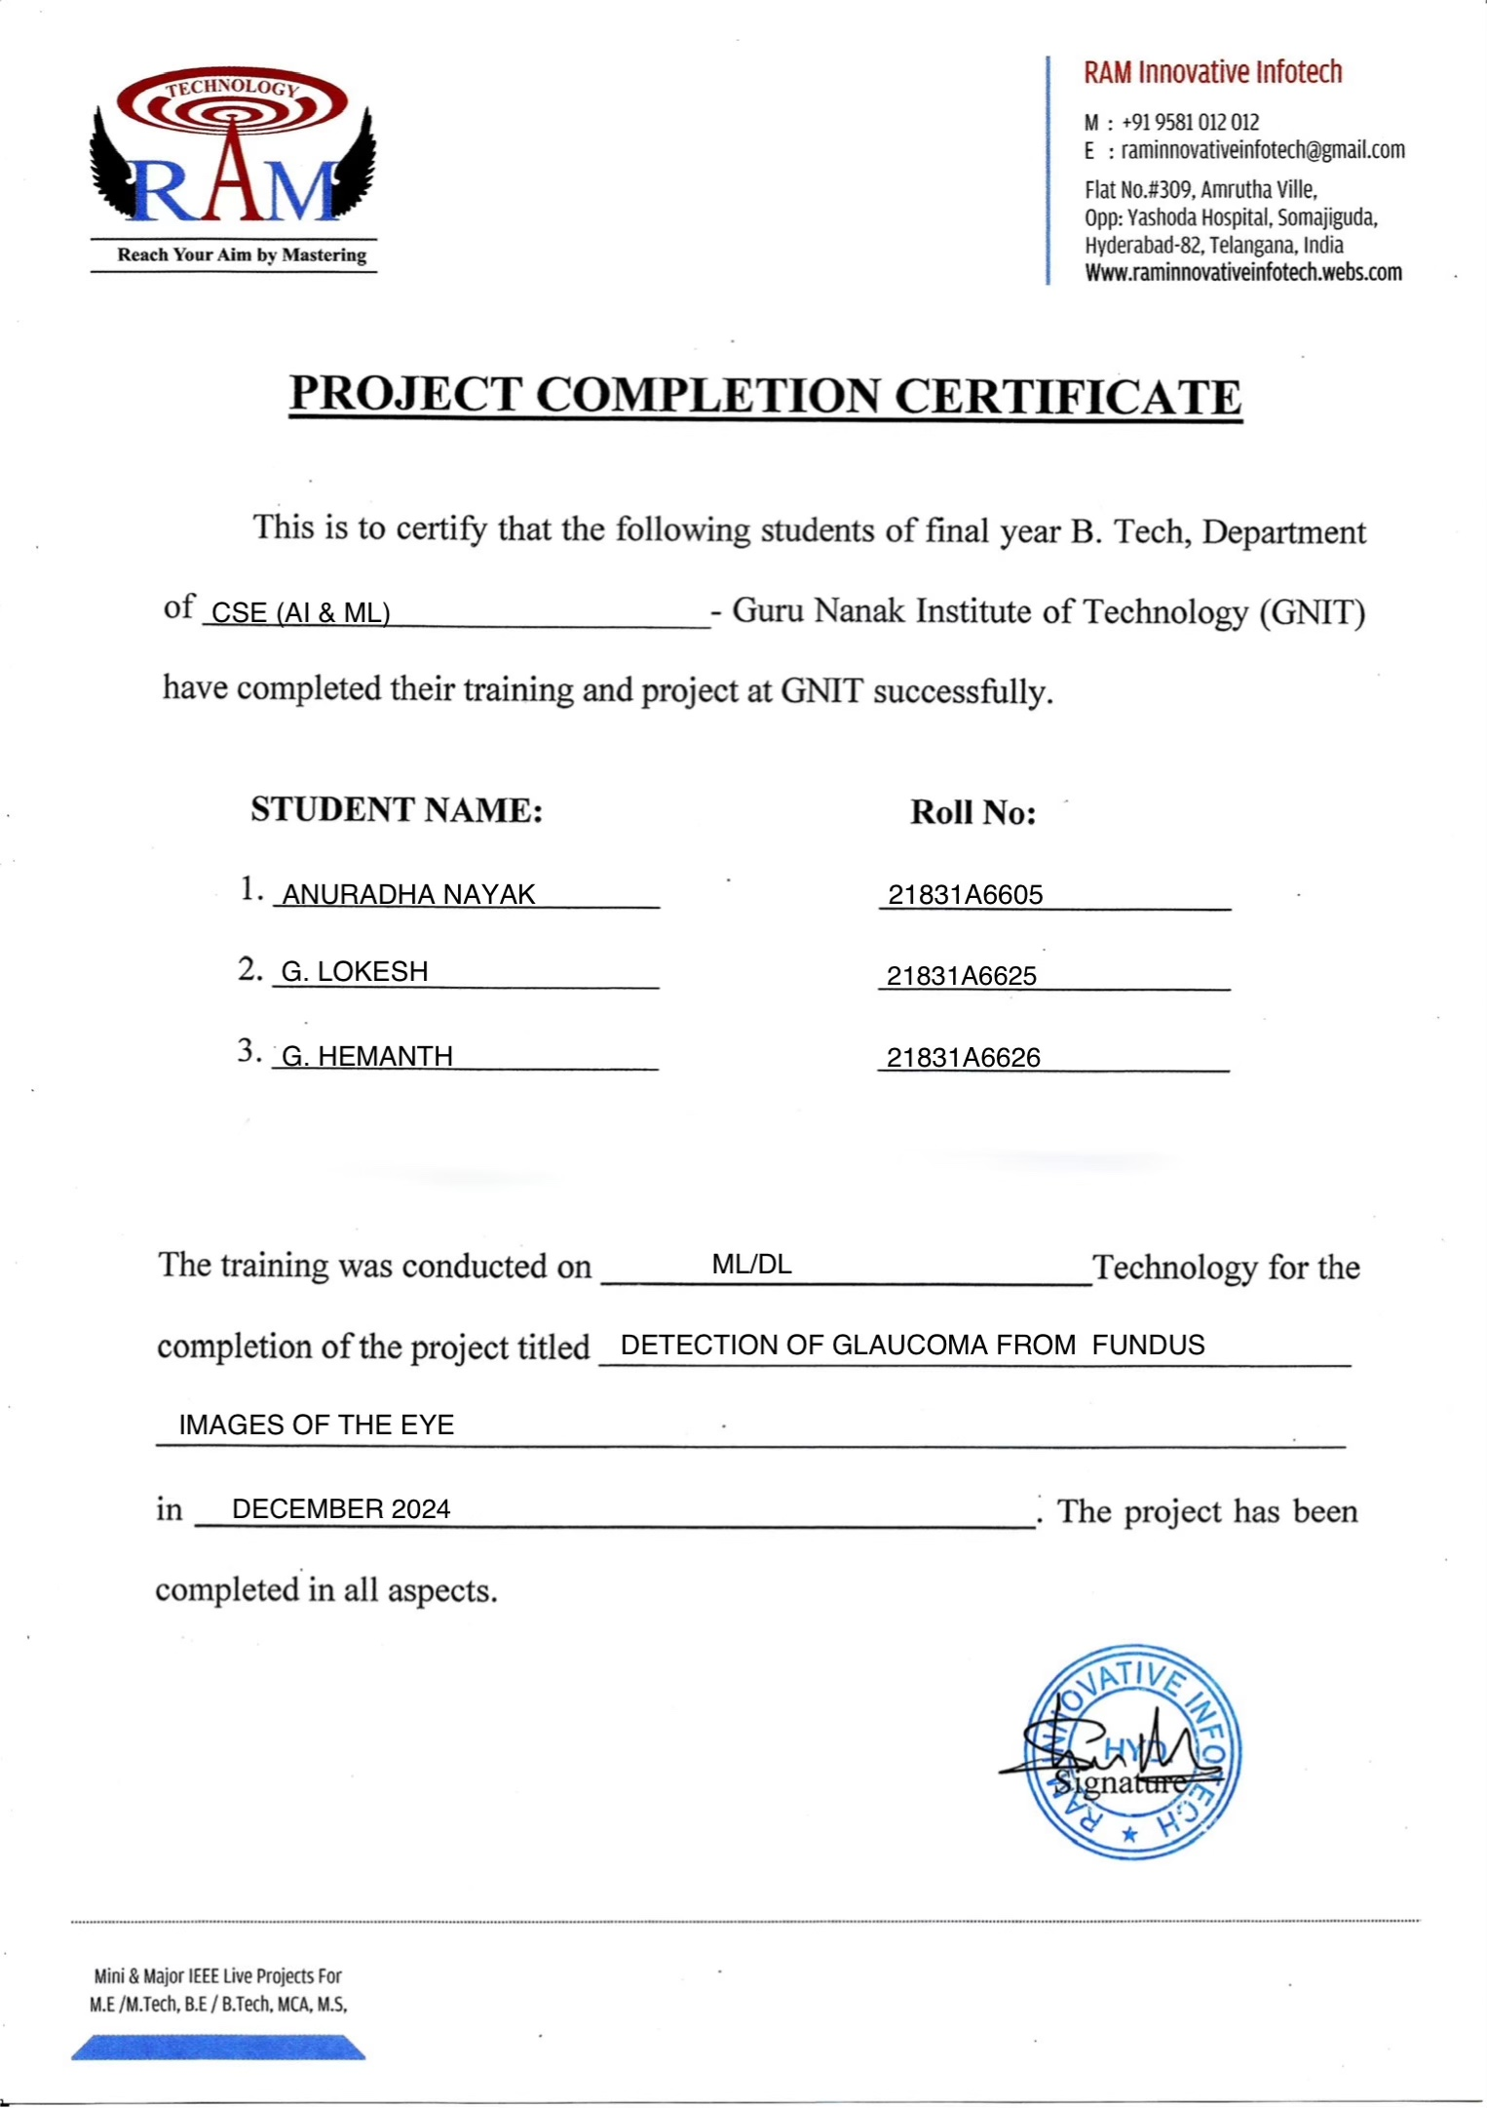



**GURU NANAK INSTITUTE OF TECHNOLOGY**

**(Autonomous)**

**Ranga Reddy District -501506**

**VISION OF GNIT**

To be a world – class educational and research institution in the service of humanity by promoting high

quality Engineering and Management Education

**MISSION OF GNIT**

M1: Imbibe soft skills and technical skills.

M2: Develop the faculty to reach the international standards.

M3: Maintain high academic standards and teaching quality that promotes the analytical thinking and independent judgment.

M4: Promote research, innovation, and product development by collaboration with reputed foreign universities.

M5: Offer collaborative industry programs in emerging areas and spirit of enterprise.

**GURU NANAK INSTITUTE OF TECHNOLOGY**

**(Autonomous)**

**Ranga Reddy District -501506**

**DEPARTMENT OF COMPUTER SCIENCE AND ENGINEERING**

**(ARTIFICIAL INTELLIGENCE AND MACHINE LEARNING)**

**VISION OF DEPARTMENT**

To become a global center of excellence in Computer Science and Engineering with a focus on Artificial Intelligence and Machine Learning, fostering innovation, research, and ethical applications to address complex real-world challenges and drive societal transformation.

**MISSION OF DEPARTMENT**

* To provide students with a robust foundation in computer science and specialized knowledge in AI and ML through innovative teaching methodologies and state-of-the-art curriculum.
* To encourage research and development in AI and ML by fostering collaboration among students, faculty, and industry for pioneering solutions to contemporary and futuristic challenges.
* To build strong industry partnerships to provide students with hands-on experience, internships, and opportunities to work on real-world AI and ML applications.
* To instil a strong sense of ethics, social responsibility, and the importance of sustainability in the development and deployment of AI and ML technologies.

**GURU NANAK INSTITUTE OF TECHNOLOGY**

**(Autonomous)**

**Ranga Reddy District -501506**

**DEPARTMENT OF COMPUTER SCIENCE AND ENGINEERING**

**(ARTIFICIAL INTELLIGENCE AND MACHINE LEARNING)**

### **PROGRAM EDUCATIONAL OBJECTIVES (PEO'S)**

**PEO-1:** Graduates will excel in core areas of computer science with a deep understanding of Artificial Intelligence and Machine Learning, enabling them to analyze, design, and implement AI- driven solutions.

**PEO-2:** Graduates will pursue advanced education, engage in cutting-edge research, and contribute to technological advancements in AI and ML.

**PEO-3:** Graduates will exhibit strong ethical values, communication skills, and teamwork capabilities while addressing societal challenges using AI and ML.

### **PROGRAM OUTCOMES (PO'S)**

**PO1: Engineering Knowledge -** Apply the knowledge of mathematics, science, engineering fundamentals, and an engineering specialization to the solution of complex engineering problems.

**PO2: Problem Analysis:** Identify, formulate, review research literature, and analyze complex engineering problems reaching substantiated conclusions using first principles of mathematics, natural sciences, and engineering sciences.

**PO3: Design/development of solutions:** Design solutions for complex engineering problems and design system components or processes that meet the specified needs with appropriate consideration for the public health and safety, and the cultural, societal, and environmental considerations.

**PO4: Conduct investigations of complex problems:** Use research-based knowledge and research methods including design of experiments, analysis and interpretation of data, and synthesis of the information to provide valid conclusions.

**PO5: Modern Tool Usage:** Create, select, and apply appropriate techniques, resources, and modern engineering and IT tools including prediction and modeling to complex engineering activities with an understanding of the limitations.

**PO6: The Engineer and Society:** Apply reasoning informed by the contextual knowledge to assess societal, health, safety, legal and cultural issues and the consequent responsibilities relevant to the professional engineering practice.

**PO7: Environment and Sustainability:** Understand the impact of the professional engineering solutions in societal and environmental contexts, and demonstrate the knowledge of, and need for sustainable development.

**PO8: Ethics:** Apply ethical principles and commit to professional ethics and responsibilities and norms of the engineering practice.

**PO9: Individual and team work:** Function effectively as an individual, and as a member or leader in diverse teams, and in multidisciplinary settings.

**PO10: Communication:** Communicate effectively on complex engineering activities with the engineering community and with society at large, such as, being able to comprehend and write effective reports and design documentation, make effective presentations, and give and receive clear instructions.

**PO11: Project Management and Finance:** Demonstrate knowledge and understanding of the engineering and management principles and apply these to one’s own work, as a member and leader in a team, to manage projects and in multidisciplinary environments.

**PO12: Lifelong Learning:** Recognize the need for, and have the preparation and ability to engage in independent and life-long learning in the broadest context of technological change.

## PROGRAM SPECIFIC OUTCOMES (PSO'S)

**PSO-1:** Graduates will be able to design, develop, and deploy AI and ML-based systems and applications to solve real-world problems, leveraging advanced algorithms, frameworks, and technologies.

**PSO-2:** Graduates will demonstrate the ability to collect, process, and analyze large datasets using data-driven approaches to build predictive and prescriptive models.

**PSO-3:** Graduates will be equipped to pursue advanced studies and contribute to cutting-edge research in AI and ML, including areas like deep learning, natural language processing, and computer vision.

**PSO-4:** Inculcate effective communication and ethics for lifelong learning with social awareness.

**GURU NANAK INSTITUTE OF TECHNOLOGY**

**(Autonomous)**

**Ranga Reddy District -501506**

**MAPPING WITH PO’S AND PSO’S**

|  |  |  |  |
| --- | --- | --- | --- |
| **Sl. No.** | **Content** | **PO’s** | **PEO’s** |
| 1 | Introduction | PO1, PO2 | PEO1 |
| 2 | Abstract | PO1, PO2 | PEO1 |
| 3 | System Specifications | PO3, PO5 | PE01 |
| 4 | Architecture Design | PO3, PO4 | PEO1, PEO2 |
| 5 | Implementation | P09, PO10, PO11 | PEO2, PEO3 |
| 6 | Results | PO4, PO11, PO12 | PEO2, PEO3 |

**GURU NANAK INSTITUTE OF TECHNOLOGY**

**(Autonomous)**

**Ranga Reddy District -501506**

**DECLARATION**

We hereby declare that the minor project report entitled “**DETECTION OF GLAUCOMA FROM FUNDUS IMAGES OF THE EYE.**” is the work done by **GANDE LOKESH, GUDLA HEMANTH, ANURADHA NAYAK** bearing the roll no’s **21831A6625, 21831A6626, 21831A6605** towards the fulfilment of the requirement for the award of the **Degree of Bachelor of Technology** in **Computer Science and Engineering (AIML)**, **Guru Nanak Institute of Technology(Autonomous)**, is the result of the work carried out under the guidance of **Mr. M. PRABHU PANDIYAN**, Assistant Professor CSE(AI&ML), Guru Nanak Institute of Technology, Hyderabad.

We further declare that this mini project report has not been previously submitted before either in part or full for the award of any degree or any diploma by any organization or any universities.

**ANURADHA NAYAK 21831A6605**

**GANDE LOKESH 21831A6625**

**GUDLA HEMANTH 21831A6626**

**ACKNOWLEDGEMENT**

**"Task successful"** makes everyone happy. But the happiness will be gold without glitter if we didn't state the persons who have supported us to make it a success.

We would like to express our sincere thanks and gratitude to our Principal **Dr . K. VENKATA RAO** and Head of the Department **Dr. B. MAHESH LOKANDE** Department of Computer Science and Engineering (Artificial Intelligence & Machine Learning), Guru Nanak Institute of Technology for guided us in developing the requisite capabilities for taking up this mini project.

We thank our Project Coordinator **Mr. E. VINAY KUMAR**, Assistant Professor, Department of Computer Science and Engineering (Artificial Intelligence & Machine Learning), Guru Nanak Institute of Technology for providing seamless support and right suggestions that are given in the development of the mini project.

We specially thank our internal guide **Mr. M. PRABHU PANDIYAN** for his constant guidance in every stage of the project. We would also like to thank all our lecturers for helping us in every possible way whenever the need arose.

On a more personal note, we thank our beloved parents and friends for their moral support during our major project.

**Detection Of Glaucoma From Fundus Images Of The Eye**

**ABSTRACT**

Glaucoma is one of the leading causes of irreversible blindness in people over 40 years old. In Colombia there is a high prevalence of the disease, being worse the fact that there is not enough ophthalmologists for the country’s population. Fundus imaging is the most used screening technique for glaucoma detection for its trade-off between portability, size and costs. In this paper we present a computational tool for automatic glaucoma detection. We report improvements for disc segmentation in comparison with other works on the literature, a novel method to segment the cup by thresholding and a new measure between the size of the cup and the size of the disc. Results were obtained from a set of fundus images in collaboration with the Centre of Prevention and Attention of Glaucoma in Bucaramanga.

**LIST OF CONTENTS**

|  |  |  |
| --- | --- | --- |
| **CHAPTER NO.** | **TITLE** | **PAGE NO.** |
|  | **Abstract**  **List of Figures**  **List of Notations**  **List of Abbreviations** | xiii  xvii  xviii - xx  xxi |
| 1. | **CHAPTER 1 : INTRODUCTION**   * 1. GENERAL   2. OBJECTIVE   3. EXISTING SYSTEM   1.3.1 EXISTING SYSTEM DISADVANTAGES  1.3.2 LITERATURE SURVEY  1.4 PROPOSED SYSTEM  1.4.1 PROPOSED SYSTEM ADVANTAGES | 1-8 |
| 2. | **CHAPTER 2 : PROJECT DESCRIPTION**  2.1 GENERAL  2.2 METHODOLOGIES  2.2.1 MODULES NAME  2.2.2 MODULES EXPLANATION  2.3 TECHNIQUE OR ALGORITHM | 9-10 |
| 3. | **CHAPTER 3 : REQUIREMENTS**  3.1 General  3.2 Hardware REQUIREMENTS  3.3 Software REQUIREMENTS  3.4 FUNCTIONAL REQUIREMENTS  3.5 NON-FUNCTIONAL REQUIREMENTS | 11-12 |
| 4. | **CHAPTER 4 : SYSTEM DESIGN**  4.1 general  4.2 USE CASE DIAGRAM  4.3 CLASS DIAGRAM  4.4 OBJECT DIAGRAM  4.5 STATE CHART DIAGRAM  4.6 COMPONENT DIAGRAM  4.7 DEPLOYMENT DIAGRAM  4.8 SEQUENCE DIAGRAM  4.9 COLLABORATION DIAGRAM  4.10 ACTIVITY DIAGRAM  4.11 DATA FLOW DIAGRAM  4.12 E-R DIAGRAM  4.13 SYSTEM ARCHITECTURE | 13-24 |
| 5. | **CHAPTER 5 :SOFTWARE SPECIFICATION**  5.1 general | 25-27 |
| 6. | **CHAPTER 6 : IMPLEMENTATION**  6.1 GENERAL  6.2 IMPLEMENTATION  6.3 DATABASE TABLE STRUCTURE | 28-49 |
| 7. | **CHAPTER 7 : SNAPSHOTS**  7.1 GENERAL  7.2 VARIOUS SNAPSHOTS | 50-53 |
| 8. | **CHAPTER 8 : SOFTWARE TESTING**  8.1 GENERAL  8.2 DEVELOPING METHODOLOGIES  8.3 TYPES OF TESTING | 54-56 |
| 9. | **CHAPTER 9: APPLICATIONS AND FUTURE ENHANCEMENt**  9.1 GENERAL  9.2 APPLICATIONS  9.3 FUTURE ENHANCEMENTS | 57-58 |
| 10. | **CHAPTER 10: CONCLUSION & REFERENCES**  10.1 CONCLUSION  10.2 REFERENCES | 59-61 |

**LIST OF FIGURES**

|  |  |  |
| --- | --- | --- |
| **FIGURE NO** | **NAME OF THE FIGURE** | **PAGE NO.** |
| 4.2 | Use Case Diagram | 14 |
| 4.3 | Class Diagram | 15 |
| 4.4 | Object Diagram | 16 |
| 4.5 | State Chart Diagram | 17 |
| 4.6 | Component Diagram | 18 |
| 4.7 | Deployment Diagram | 18 |
| 4.8 | Sequence Diagram | 19 |
| 4.9 | Collaboration Diagram | 20 |
| 4.10 | Activity Diagram | 21 |
| 4.11 | Data Flow Diagram | 22 |
| 4.13 | E-R Diagram | 23 |
| 4.14 | System Architecture | 24 |
| 5.1 | NumPy, Pandas, Matplotlib, Scikit-learn | 27 |
| 7.2.1 | Digital Fundus Image | 50 |
| 7.2.2 | Segmented OD | 51 |
| 7.2.3 | Cropped ROI | 51 |
| 7.2.4 | Optic Cup and Optic Disc Localization | 52 |
| 7.2.5 | Detection of Fundus Lesions | 53 |

**LIST OF NOTATIONS**

|  |  |  |  |  |  |
| --- | --- | --- | --- | --- | --- |
| **S.NO** | **NAME** | **NOTATION** | | **DESCRIPTION** | |
| 1. | Class | *Class Name*  *-attribute-attribute*  *+operation*  *+operation*  *+operation*  *+ public*  *-private*  *# protected* | | Represents a collection of similar entities grouped together. | |
| 2. | Association | name  Class B  Class A  Class A  Class B | | Associations represents static relationships between classes. Roles represents the way the two classes see each other. | |
| 3. | Actor | Class A  Class A  Class B  Class B | | It aggregates several classes into a single classis | |
| 5. | Aggregation | Interaction between the system and external environment | |
| 5. | Relation  (uses) | | Uses | | Used for additional process communication. | |
| 6. | Relation  (extends) | | extends | | Extends relationship is used when one use case is similar to another use case but does a bit more. | |
| 7. | Communication | |  | | Communication between various use cases. | |
| 8. | State | | State | | State of the process. | |
| 9. | Initial State | |  | | Initial state of the object | |
| 10. | Final state | |  | | Final state of the object | |
| 11. | Control flow | |  | | Represents various control flow between the states. | |
| 12. | Decision box | |  | | Represents decision making process from a constraint | |
| 13. | Use case | |  | | Interact ion between the system and external environment. | |
| 14. | Component | |  | | Represents physical modules which is a collection of components. | |
| 15. | Node | |  | | Represents physical modules which are a collection of components. | |
| 16. | Data Process / State | |  | | A circle in DFD represents a state or process which has been triggered due to some event or action. | |
| 17. | External entity | |  | | Represents external entities such as keyboard, sensors, etc. | |
| 18. | Transition | |  | | Represents communication that occurs between processes. | |
| 19. | Object Lifeline | |  | | Represents the vertical dimensions that the object communications. | |
| 20. | Message | | Message | | Represents the message exchanged. | |

**LIST OF ABBREVATION**

|  |  |  |
| --- | --- | --- |
| **S.NO** | **ABBREVATION** | **EXPANSION** |
| 1**.** | DB | Data Base |
| 2. | JVM | Java Virtual Machine |
| 3. | JSP | Java Server Page |
| 4. | PWS | personalised web search | |
| 5. | UPS | user personalised search |
| 6. | JRE | Java Runtime Environment |

**CHAPTER 1**

**INTRODUCTION**

* 1. **GENERAL**

Glaucoma is the first cause of irreversible blindness since it affects the eye’s optic nerve. In most of the cases patients do not experience symptoms of vision loss until advanced stages. According to Mohammadi and Jeyaraman, it is estimated that in developed countries, at least half of glaucoma patients feel no signals of the disease, which is expected to be worse in developing countries. In a study of glaucoma prevalence from worldwide published data found that by 2020, over 11.1 million people will be bilaterally blind from primary glaucoma. In was also reported the increasing economic cost of treatment of glaucoma in advanced stages. In Colombia, the Ministry of Health and Social Security estimates that there is around 296,000 blind people for several causes, having glaucoma a prevalence of 3.9% in people over 40 years old in Bucaramanga. This gets worse by the fact that in the country, based on the population in 2011, there are 2 ophthalmologists for 100,000 patients.

**1.2 OBJECTIVE**

In this paper we present a computational tool for automatic glaucoma detection. We report improvements for disc segmentation in comparison with other works on the literature, a novel method to segment the cup by thresholding and a new measure between the size of the cup and the size of the disc.

**1.3 Existing System:**

The damage in the optic nerve is due to elevated pressure in the eye, which is caused by either overproduction of aqueous humour or by the blockage of the drainage system of this liquid. There is also evidence of the incidence of genetic family background in the appearance of the disease. There are several tests that can be performed in a patient with suspected glaucoma, such as tonometry to measure the eye’s pressure, gonioscopy to see if angle is open or closed, optical coherence tomography (OCT) and fundoscopy.

**1.3.1 Existing System Disadvantages:**

The disadvantages of the existing system for glaucoma detection include:

* **Invasive or Uncomfortable Procedures:** Some tests, such as tonometry or gonioscopy, can be uncomfortable or invasive, which might deter patients from regular check-ups.
* **Limited Accessibility:** Advanced diagnostic tools like Optical Coherence Tomography (OCT) may not be widely available in rural or underserved areas due to high costs and specialized equipment requirements.
* **Dependence on Skilled Professionals:** Tests such as fundoscopy and gonioscopy require trained ophthalmologists, limiting their accessibility in regions with a shortage of specialists.
* **Cost Implications:** Comprehensive glaucoma diagnosis can be expensive, making it less affordable for low-income patients.
* **Potential for Missed Diagnoses:** In some cases, subtle changes in the optic nerve or intraocular pressure my not be detected early, leading to delayed treatment.

**1.3.2 LITERATURE SURVEY:**

**Title:** The Effectiveness of Tele glaucoma versus In-Patient Examination for Glaucoma Screening: A Systematic Review and Meta-Analysis

**Author:** Sera-Melisa Thomas , Maya M Jeyaraman.

**Year:** 2014

Description: Glaucoma is the leading cause of irreversible visual impairment in the world affecting 60.5 million people worldwide in 2010, which is expected to increase to approximately 79.6 million by 2020. Therefore, glaucoma screening is important to detect, diagnose, and treat patients at the earlier stages to prevent disease progression and vision loss. Teleglaucoma uses stereoscopic digital imaging to take ocular images, which are transmitted electronically to an ocular specialist. The purpose is to synthesize literature to evaluate teleglaucoma, its diagnostic accuracy, healthcare system benefits, and cost-effectiveness. Methods: A systematic search was conducted to help locate published and unpublished studies. Studies which evaluate teleglaucoma as a screening device for glaucoma were included. A meta-analysis was conducted to provide estimates of diagnostic accuracy, diagnostic odds ratio, and the relative percentage of glaucoma cases detected. The improvements to healthcare service quality and cost data were assessed. Results: Of 11237 studies reviewed, 45 were included. Our results indicated that, teleglaucoma is more specific and less sensitive than in-person examination. The pooled estimates of sensitivity was 0.832 [95% CI 0.770, 0.881] and specificity was 0.790 [95% CI 0.668, 0.876]. The relative odds of a positive screen test in glaucoma cases are 18.7 times more likely than a negative screen test in a non-glaucoma cases. Additionally, the mean cost for every case of glaucoma detected was $1098.67 US and of teleglaucoma per patient screened was $922.77 US. Conclusion: Teleglaucoma can accurately discriminate between screen test results with greater odds for positive cases. It detects more cases of glaucoma than in-person examination. Both patients and the healthcare systems benefit from early detection, reduction in wait and travel times, increased specialist referral rates, and cost savings. Teleglaucoma is an effective screening tool for glaucoma specifically for remote and under-services communities.

**Title:** An Assessment of the Health and Economic Burdens of Glaucoma

**Author:** Rohit Varma , Paul Lee.

**Year:** 2011

**Description:** To bring together information concerning the epidemiology and the economic and individual burdens of glaucoma. Interpretive essay. Review and synthesis of selected literature published from 1991 through December 2010. An estimated 3% of the global population over 40 years of age currently has glaucoma, the majority of whom are undiagnosed. Vision loss from glaucoma has a significant impact on health-related quality of life even in the early stages of disease. The overall burden increases as glaucomatous damage and vision loss progress. The economic burden of glaucoma is significant and increases as the disease worsens. Early identification and treatment of patients with glaucoma and those with ocular hypertension at high risk of developing vision loss are likely to reduce an individual's loss of health-related quality of life as well as the personal and societal economic burdens.

**Title:** The number of people with glaucoma worldwide in 2010 and 2020

**Author:** Harry A. Quigley, A.T. Broman.

**Year:** 2006

**Description:** To estimate the number of people with open angle (OAG) and angle closure glaucoma (ACG) in 2010 and 2020. A review of published data with use of prevalence models. Data from population based studies of age specific prevalence of OAG and ACG that satisfied standard definitions were used to construct prevalence models for OAG and ACG by age, sex, and ethnicity, weighting data proportional to sample size of each study. Models were combined with UN world population projections for 2010 and 2020 to derive the estimated number with glaucoma. There will be 60.5 million people with OAG and ACG in 2010, increasing to 79.6 million by 2020, and of these, 74% will have OAG. Women will comprise 55% of OAG, 70% of ACG, and 59% of all glaucoma in 2010. Asians will represent 47% of those with glaucoma and 87% of those with ACG. Bilateral blindness will be present in 4.5 million people with OAG and 3.9 million people with ACG in 2010, rising to 5.9 and 5.3 million people in 2020, respectively. Glaucoma is the second leading cause of blindness worldwide, disproportionately affecting women and Asians.

**Title:** Review of automated glaucoma detection techniques

**Author:** Sharanagouda Nawaldgi

**Year:** 2016

**Description:** Glaucoma, an eye disease, is often referred to as the silent thief of sight. The damage done by glaucoma is irreversible. Early detection and treatment of glaucoma is the only solution. Till date many works have been done towards automatic glaucoma detection using Color Fundus Images (CFI) and Optical Coherence Tomography (OCT) images by extracting structural features. Structural features can be extracted from optic nerve head (ONH) analysis in case of CFI and Retinal Layers (RL) analysis in OCT images for glaucoma assessment. But unfortunately, the works till date fall short of expected accuracy in this regard. A review of automated glaucoma detection techniques is presented in this paper. The paper also discusses various structural features that are relevant to CFI and OCT images respectively for automated glaucoma detection. The paper concludes that combining structural features from both CFI and OCT images would result in more accurate glaucoma assessment.

**Title:** Image Processing Techniques for Glaucoma Detection Using the Cup-to-Disc Ratio

**Author:** C. Anusorn, W. Kongprawechnon, T. Kondo, S. Sintuwong

**Year:** 2013

**Description:** Glaucoma is the second leading cause of permanent blindness worldwide. Early detection of glaucoma can limit the disease progression. The ratio of the size of the optic cup to the optic disc, also known as the cup-to-disc ratio (CDR), is one of the important clinical indicators of glaucoma, and is currently determined manually by trained ophthalmologists, limiting its potential in mass screening for early detection. In this paper, the authors propose a method to calculate the CDR automatically from nonstereographic retinal fundus photographs taken from a NIDEK AFC-230, which is a non-mydriatic auto fundus camera. To automatically extract the disc, two methods making use of an edge detection method and variational level-set method are proposed in the paper. For the cup, colour component analysis and threshold level-set method are evaluated. To reshape the obtained disc and cup boundary from our methods, ellipse fitting is applied to the obtained image. A set of 44 retinal images obtained from Mettapracharak Hospital, Nakhon Pathom Thailand is used to assess the performance of the determined CDR to the clinical CDR, and it is found that our proposed method provides 89% accuracy in the determined CDR results.

* 1. **Proposed System**

The retinal fundus image is used to measure the thickness of the retinal nerve fibre layer (RNFL) to diagnose glaucoma. It is one of the non-invasive techniques most used by ophthalmologists. Its major advantage is that images can be taken easily for either healthy and nonhealthy retinas , it is also portable and not difficult to use for any health professional, especially in screening campaigns among population without access to health care services. The thickness of the RNFL is calculated by measuring the proportion among the size of the optic nerve (named disc) and the size of the excavation inside the optic nerve produced by the increasing eye’s pressure (named cup). This parameter is known as the Cup-to-Disc ratio (CDR).

**1.4.1 Proposed System Advantages**

The proposed system focuses on using **retinal fundus imaging** to diagnose glaucoma by measuring the **retinal nerve fiber layer (RNFL) thickness**. Here are its advantages:

* **Non-Invasive**: The use of retinal fundus imaging is a non-invasive method, making it patient-friendly and safe.
* **Accessibility**: The system is portable and easy to use, enabling health professionals to perform screenings even in remote areas or among populations lacking access to healthcare.
* **Versatility**: It works effectively for both healthy and non-healthy retinas, increasing its utility in diverse patient groups.
* **Efficiency in Diagnosis**: By calculating the **Cup-to-Disc Ratio (CDR)**, the system provides an objective measure to evaluate the thickness of the RNFL and detect glaucoma.
* **Support for Screening Campaigns**: Its portability and simplicity make it ideal for large-scale screening programs.

**CHAPTER - 2**

**PROJECT DESCRIPTION**

**2.1 GENERAL**

The damage in the optic nerve is due to elevated pressure in the eye, which is caused by either overproduction of aqueous humour or by the blockage of the drainage system of this liquid.

**2.2 METHODOLOGIES :**

**2.2.1 MODULE NAME:**

* Input Image
* Preprocessing
* Segmentation
* Feature Extraction
* Detection

**2.2.2 METHODOLOGIES EXPLANATION:**

* **Input Image**

The retinal fundus image is used to measure the thickness of the retinal nerve fiber layer (RNFL) to diagnose glaucoma. It is one of the noninvasive techniques most used by ophthalmologists. Its major advantage is that images can be taken easily for either healthy and nonhealthy retinas.

* **IMAGE PREPROCESSING:**

The image of the fungus is pre-processed through a series of processesnamely image segmentation and feature extraction. This process is done so that it can be used in the process of Retinal Vessel Segmentation.

* **SEGMENTATION:**

We propose the cup and disc segmentation using RGB and HSV color models and K-mean clustering. The method has 92% of accuracy, but they do not take into account the vascular system that goes throughout the disc which interferes with the precision of detecting the correct pixels that belong to the disc.

* **FEATURE EXTRACTION:**

Feature extraction is a process of dimensionality reduction by which an initial set of raw data is reduced to more manageable groups for processing. A characteristic of these large data sets is a large number of variables that require a lot of computing resources to process.

* **DETECTION:**

The measurements over a set of fundus images of both healthy and non-healthy eyes, where the ophthalmologists provided their estimated CDR for each image. Results coming from our algorithm were compared with those reference estimations. where are presented the comparisons between the doctor estimation, the output with the algorithm of ratio of ratios and the output of the algorithm of proportion of areas.

**2.3 Technique or Algorithm**

**Algorithm: Retinal Vessel Segmentation**

* **Purpose**:
  + Identifies and analyzes the retinal vascular system, which acts as a biomarker for glaucoma and other diseases.
* **Steps**:
  + Preprocess the retinal image to highlight vessels.
  + Segment the vessels using clustering algorithms (e.g., K-means).
  + Analyze vascular patterns and calculate key parameters like CD.

**CHAPTER 3**

**REQUIREMENTS ENGINEERING**

**3.1 GENERAL**

In this work we present a computational tool for automatic glaucoma detection from fundus images of the eye. We propose a novel method for cup segmentation, which shows an improvement in the accuracy compared to other methods. The algorithms have been tested using a set of images provided by the Prevention and Attention centre of Glaucoma in Bucaramanga, Colombia.

**3.2 HARDWARE REQUIREMENTS**

The hardware requirements may serve as the basis for a contract for the implementation of the system and should therefore be a complete and consistent specification of the whole system. They are used by software engineers as the starting point for the system design. It should what the system do and not how it should be implemented.

* PROCESSOR : DUAL CORE 2 DUOS.
* RAM : 4GB DD RAM
* HARD DISK : 250 GB

**3.3 SOFTWARE REQUIREMENTS**

The software requirements document is the specification of the system. It should include both a definition and a specification of requirements. It is a set of what the system should do rather than how it should do it. The software requirements provide a basis for creating the software requirements specification. It is useful in estimating cost, planning team activities, performing tasks and tracking the teams and tracking the team’s progress throughout the development activity.

**SOFTWARE REQUIREMENTS**

* Operating System : Windows 7/8/10
* Platform : Spyder3
* Programming Language : Python, HTML
* Front End : Spyder3

**3.4 FUNCTIONAL REQUIREMENTS**

A functional requirement defines a function of a software-system or its component. A function is described as a set of inputs, the behavior, Firstly, the system is the first that achieves the standard notion of semantic security for data confidentiality in attribute-based deduplication systems by resorting to the hybrid cloud architecture.

**3.5 NON-FUNCTIONAL REQUIREMENTS**

Our multi-modal event tracking and evolution framework is suitable for multimedia documents from various social media platforms, which can not only effectively capture their multi-modal topics, but also obtain the evolutionary trends of social events and generate effective event summary details over time. Our proposed mmETM model can exploit the multi-modal property of social event, which can effectively model social media documents including long text with related images and learn the correlations between textual and visual modalities to separate the visual-representative topics and non-visual-representative topics.

**CHAPTER 4**

**DESIGN ENGINEERING**

**4.1 GENERAL**

Design Engineering deals with the various UML [Unified Modelling language] diagrams for the implementation of project. Design is a meaningful engineering representation of a thing that is to be built. Software design is a process through which the requirements are translated into representation of the software. Design is the place where quality is rendered in software engineering. Design is the means to accurately translate customer requirements into finished product.

**4.2 Use Case Diagram**

**UML Diagrams**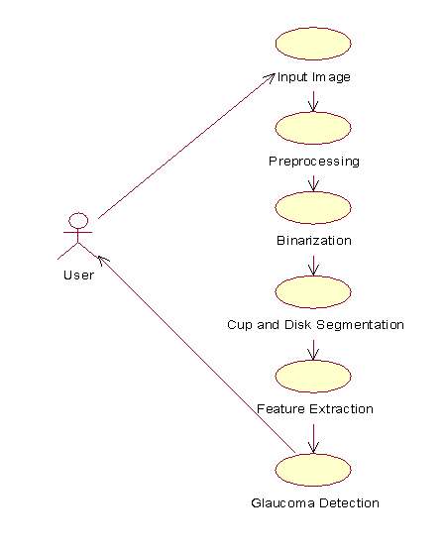

**Fig 4.2 Use case diagram**

**EXPLANATION:**

The main purpose of a use case diagram is to show what system functions are performed for which actor. Roles of the actors in the system can be depicted. The above diagram consists of user as actor. Each will play a certain role to achieve the concept.

**4.3 Class Diagram**

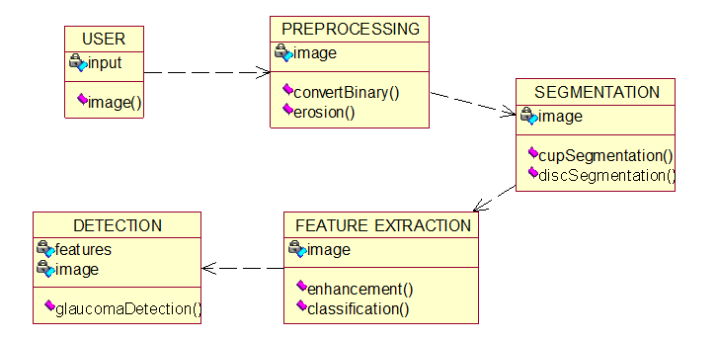

**Fig 4.3 Class Diagram**

**EXPLANATION**

In this class diagram represents how the classes with attributes and methods are linked together to perform the verification with security. From the above diagram shown the various classes involved in our project.

**4.4 Object Diagram**

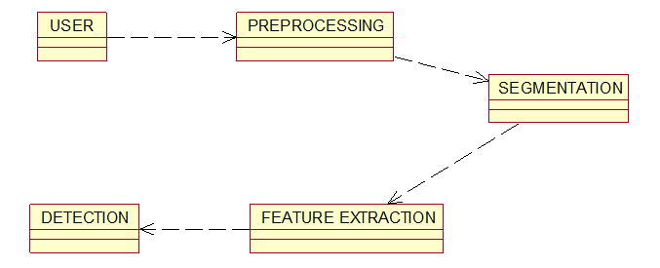

**Fig 4.4 Object Diagram**

**EXPLANATION:**

In the above diagram tells about the flow of objects between the classes. It is a diagram that shows a complete or partial view of the structure of a modelled system. In this object diagram represents how the classes with attributes and methods are linked together to perform the verification with security.

**4.5 State Chart Diagram**

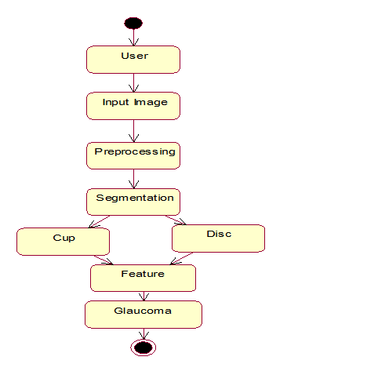

**Fig 4.5 State Chart Diagram**

**EXPLANATION:**

State diagram are a loosely defined diagram to show workflows of stepwise activities and actions, with support for choice, iteration and concurrency. State diagrams require that the system described is composed of a finite number of states; sometimes, this is indeed the case, while at other times this is a reasonable abstraction. Many forms of state diagrams exist, which differ slightly and have different semantics.

**4.6 Component Diagram**

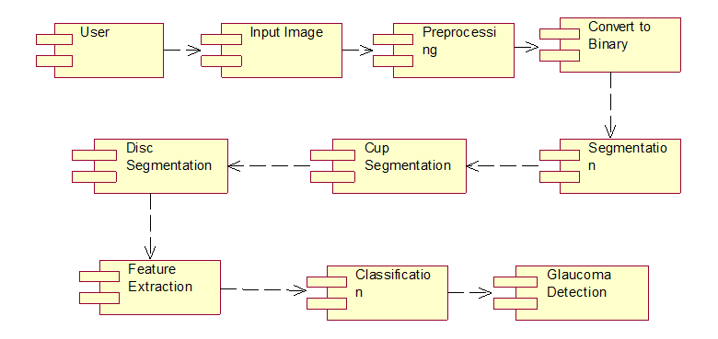

**Fig 4.6 Component Diagram**

**4.7 Deployment Diagram**

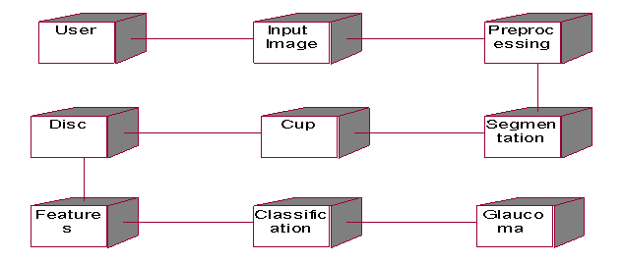

**Fig 4.7 Deployment Diagram**

**4.8 Sequence Diagram**

.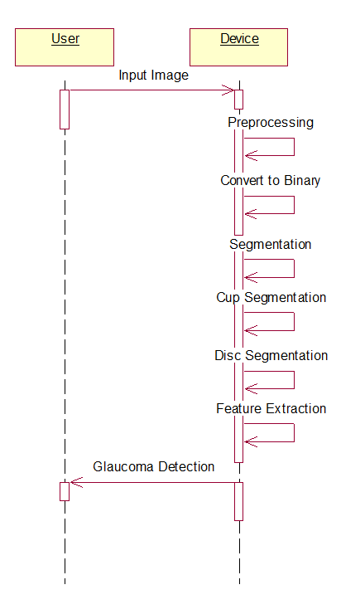

**Fig 4.8 Sequence Diagram**

**EXPLANATION:**

Activity diagrams are graphical representations of workflows of stepwise activities and actions with support for choice, iteration and concurrency. In the Unified Modelling Language, activity diagrams can be used to describe the business and operational step-by-step workflow of components in a system. An activity diagram shows the overall flow of control

**4.9 Collaboration Diagram**

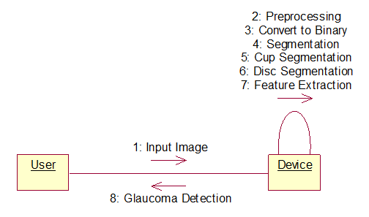

**Fig 4.9 Collaboration Diagram**

**4.10 Activity Diagram**

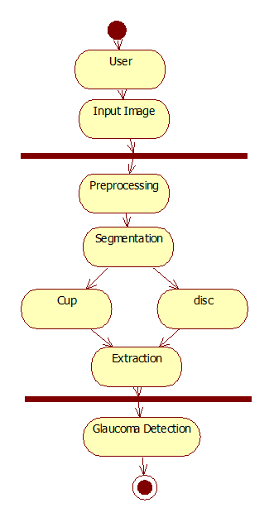

**Fig 4.10 Activity Diagram**

**EXPLANATION:**

Activity diagrams are graphical representations of workflows of stepwise activities and actions with support for choice, iteration and concurrency. In the Unified Modelling. Language, activity diagrams can be used to describe the business and operational step-by-step workflows of components in a system. An activity diagram shows the overall flow of control

**4.11 Data Flow Diagram**

**Level 0**

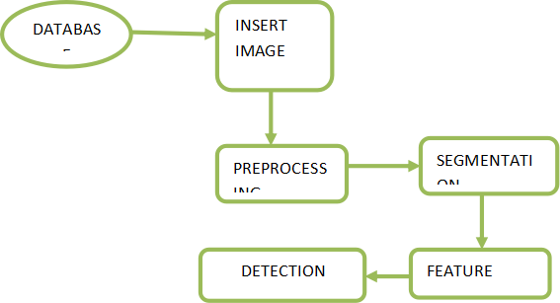

**Fig 4.11 Data Flow Diagram**

**Level 1**

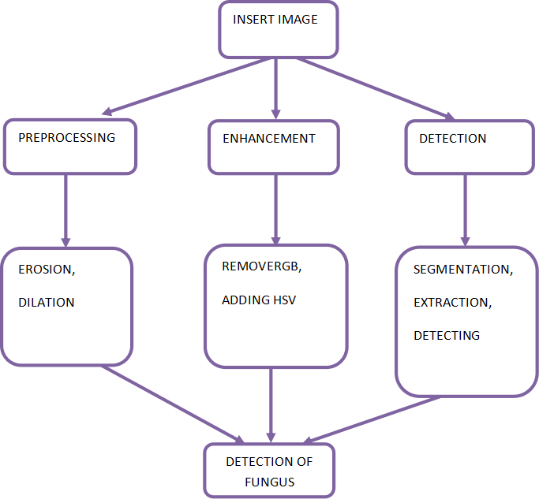

**EXPLANATION:**

A data flow diagram (DFD) is a graphical representation of the "flow" of data through an information system, modelling its process aspects. Often they are a preliminary step used to create an overview of the system which can later be elaborated. DFDs can also be used for the visualization of data processing (structured design).A DFD shows what kinds of data will be input to and output from the system, where the data will come from and go to, and where the data will be stored. It does not show information about the timing of processes, or information about whether processes will operate in sequence or in parallel.

**4.12 E-R Diagram**

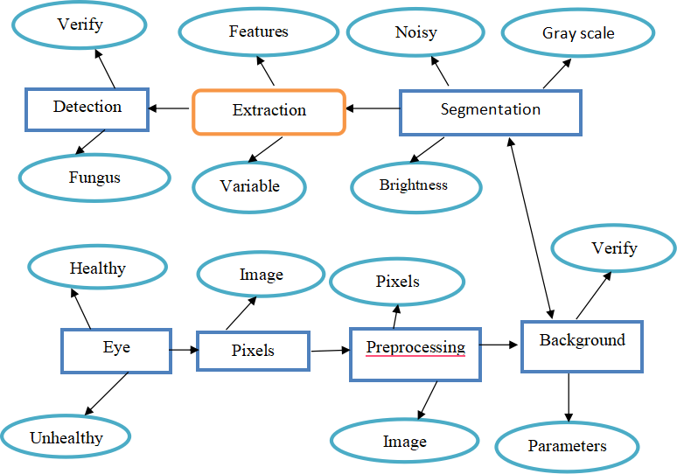

**Fig 4.12 E-R Diagram**

**EXPLANATION:**

Entity-Relationship Model (ERM) is an abstract and conceptual representation of data. Entity-relationship modelling is a database modelling method, used to produce a type of conceptual schema or semantic data model of a system, often a relational database

**4.13 System Architecture**

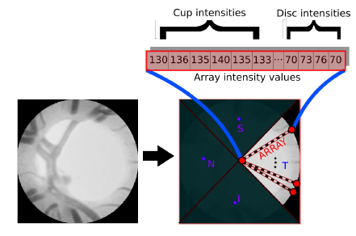

**Fig 4.13 System Architecture**

**CHAPTER 5**

**DEVELOPMENT TOOLS**

**5.1 General:**

**Python**

Python is a high-level, interpreted, interactive and object-oriented scripting language. Python is designed to be highly readable. It uses English keywords frequently where as other languages use punctuation, and it has fewer syntactical constructions than other languages.

**History of Python**

Python was developed by Guido van Rossum in the late eighties and early nineties at the National Research Institute for Mathematics and Computer Science in the Netherlands.

Python is derived from many other languages, including ABC, Modula-3, C, C++, Algol-68, Smalltalk, and Unix shell and other scripting languages.

Python is copyrighted. Like Perl, Python source code is now available under the GNU General Public License (GPL).

Python is now maintained by a core development team at the institute, although Guido van Rossum still holds a vital role in directing its progress.

**Importance of Python**

* **Python is Interpreted** − Python is processed at runtime by the interpreter. You do not need to compile your program before executing it. This is similar to PERL and PHP.
* **Python is Interactive** − You can actually sit at a Python prompt and interact with the interpreter directly to write your programs.
* **Python is Object-Oriented** − Python supports Object-Oriented style or technique of programming that encapsulates code within objects.
* **Python is a Beginner's Language** − Python is a great language for the beginner-level programmers and supports the development of a wide range of applications from simple text processing to WWW browsers to games.

**Features of Python**

* **Easy-to-learn** − Python has few keywords, simple structure, and a clearly defined syntax. This allows the student to pick up the language quickly.
* **Easy-to-read** − Python code is more clearly defined and visible to the eyes.
* **Easy-to-maintain** − Python's source code is fairly easy-to-maintain.
* **A broad standard library** − Python's bulk of the library is very portable and cross- to many system calls, libraries and windows systems, such as Windows MFC, Macintosh, platform compatible on UNIX, Windows, and Macintosh.
* **Interactive Mode** − Python has support for an interactive mode which allows interactive testing and debugging of snippets of code.
* **Portable** − Python can run on a wide variety of hardware platforms and has the same interface on all platforms.
* **Extendable** − You can add low-level modules to the Python interpreter. These modules enable programmers to add to or customize their tools to be more efficient.
* **Databases** − Python provides interfaces to all major commercial databases.
* **GUI Programming** − Python supports GUI applications that can be created and ported and the X Window system of Unix.
* **Scalable** − Python provides a better structure and support for large programs than shell scripting.

Apart from the above-mentioned features, others are mentioned below.

* It supports functional and structured programming methods as well as OOP.
* It can be used as a scripting language or can be compiled to byte-code for building large applications.
* It provides very high-level dynamic data types and supports dynamic type checking.
* IT supports automatic garbage collection.
* It can be easily integrated with C, C++, COM, ActiveX, CORBA, and Java.
* **Libraries used in python:**
* NumPy - mainly useful for its N-dimensional array objects.
* Pandas - Python data analysis library, including structures such as dataframes.
* matplotlib - 2D plotting library producing publication quality figures.
* Scikit-learn - the machine learning algorithms used for data analysis and data mining tasks.

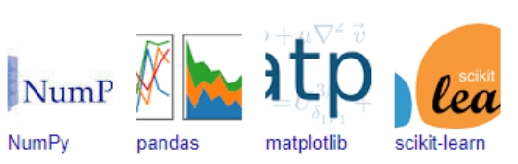

**Fig 5.1 NumPy, Pandas, Matplotlib, Scikit-learn**

**CHAPTER 6**

**IMPLEMENTATION**

**6.1 GENERAL**

**Coding:**

import os

from platform import python_version_tuple

if python_version_tuple()[0] == 3:

xrange = range

import numpy as np

import pandas as pd

import cv2

import imhandle as imh

HEALTHY = 0

GLAUCOMA_OR_SUSPECT = 1

def extract_DRIONS_DB(db_folder, expert=1):

"""

Full images with polygonal optic disc segmentation from 2 experts.

400 x 600 original, 560 x 560 after post-processing.

Images have unwanted text at the left, so it needs to be dropped out.

Accepted values for `expert`: 1, 2.

Required schema:

db_folder/

images/

image_{:03}.jpg

experts_annotation/

anotExpert1_{:03}.txt

anotExpert2_{:03}.txt

"""

orig_resolution = (400, 600)

left_cut_thr = 40

result_resolution = (orig_resolution[1] - left_cut_thr, orig_resolution[1] - left_cut_thr)

X, filenames = imh.load_set(os.path.join(db_folder, 'images'))

file_codes = [fn[-7:-4] for fn in filenames]

Y = []

for i, code in enumerate(file_codes):

anot_filename = os.path.join(db_folder, 'experts_annotation', 'anotExpert{}_{}.txt'.format(expert, code))

with open(anot_filename) as anot_fin:

coords = anot_fin.readlines()

coords = map(lambda s: map(lambda x: int(round(float(x))), s.split(' , ')),

coords)

coords = np.array(coords)

segm_img = np.zeros(orig_resolution, dtype=np.uint8)

cv2.fillPoly(segm_img, coords.reshape((1,) + coords.shape), color=1)

Y.append(segm_img)

for i in xrange(len(X)):

side = result_resolution[0]

X[i] = imh.resize_image_to_square(X[i][:, left_cut_thr:], side, pad_cval=0)

Y[i] = imh.resize_image_to_square(Y[i][:, left_cut_thr:], side, pad_cval=0)

Y[i] = Y[i].reshape(Y[i].shape + (1,))

return X, Y, file_codes

def get_resolution_DRIONS_DB():

"""Returns DRIONS_DB resolution after post-processing."""

return (560, 560)

def extract_RIM_ONE_v2(db_folder):

"""

Cropped (to optic disc region) images with polygonal optic disc segmentation.

380 x 394 original, 394 x 394 after post-processing.

Required schema:

db_folder/

Normal/

im{:03}.jpg (number from 0 to 255)

im{:03}_gs.txt

Glaucoma and glaucoma suspicious/

im{:03}.jpg (number from 256 to 455)

im{:03}_gs.txt

"""

orig_resolution = (380, 394)

result_resolution = (394, 394)

X_all, Y_all, filecodes_all, is_ill = [], [], [], []

for pic_type in ('Normal', 'Glaucoma and glaucoma suspicious'):

X, filenames = imh.load_set(os.path.join(db_folder, pic_type))

file_codes = [fn[-7:-4] for fn in filenames]

Y = []

for i, code in enumerate(file_codes):

anot_filename = os.path.join(db_folder, pic_type, 'Im{}-gs.txt'.format(code))

with open(anot_filename) as anot_fin:

lines = anot_fin.readlines()

'''

# polygonal segmentation

coords = lines[1:lines.index('Ellipse parameters\r\n')]

coords = np.array(map(int, coords))

if coords.size % 2 != 0:

raise imh.ImLibException('n_coords % 2 != 0')

coords = coords.reshape((coords.size / 2, 2))

coords = coords[1:] # optic disc center point is included in annotation for some reason

segm_img = np.zeros(orig_resolution, dtype=np.uint8)

cv2.fillPoly(segm_img, coords.reshape((1,) + coords.shape), color=1)

'''

'''

# ellipse segmentation

coords = lines[lines.index('Ellipse parameters\r\n') + 1:]

coords = map(int, coords)

i0, j0, a, b, angle = coords

a /= 2

b /= 2

segm_img = np.zeros(orig_resolution, dtype=np.uint8)

cv2.ellipse(segm_img, (i0, j0), (a, b), angle, 0, 360, color=1, thickness=-1)

'''

# acquiring segmentation from pre-computed image

segm_img = imh.load_image(os.path.join(db_folder, pic_type + ' segmentation', 'Im{}-gs_mask.jpg'.format(code))

Y.append(segm_img)

is_ill.append(HEALTHY if pic_type == 'Normal' else GLAUCOMA_OR_SUSPECT)

for i in xrange(len(X)):

side = result_resolution[0]

X[i] = imh.resize_image_to_square(X[i], side, pad_cval=0)

Y[i] = imh.resize_image_to_square(Y[i], side, pad_cval=0)

Y[i] = Y[i].reshape(Y[i].shape + (1,))

X_all.extend(X)

Y_all.extend(Y)

filecodes_all.extend(file_codes)

return X_all, Y_all, filecodes_all, is_ill

def get_resolution_RIM_ONE_v2():

"""Returns RIM_ONE_v2 resolution after post-processing."""

return (394, 394)

def extract_RIM_ONE_v3(db_folder, expert='avg', return_disc=True, return_cup=True):

"""

Cropped (to optic disc region, and a little more by vertical axis) images

with polygonal optic disc segmentation. 1424 x 2144 original, 1424 x 1424 after post-processing.

Images are two-channel (stereo) --- caught from 2 angles.

But segmentation is given for only one view (see L/R letter in file name for clarification).

So only one view of two is chosen

Accepted values for `expert`: 1, 2, 'avg'.

Required schema:

db_folder/

Healthy/

Stereo Images/

N-{}-[L,R].jpg (number is without leading zeros, from 1 to 92)

(image cannot be used as is. it is two-part image, divided by vertical border)

Expert1_masks/

N-{}-[L,R]-Cup-exp1.png (4 files for one image number and L/R characteristic)

N-{}-[L,R]-Cup-exp1.txt

N-{}-[L,R]-Disc-exp1.png

N-{}-[L,R]-Disc-exp1.txt

Expert2_masks/

N-{}-[L,R]-Cup-exp2.png (4 files for one image number and L/R characteristic)

N-{}-[L,R]-Cup-exp2.txt

N-{}-[L,R]-Disc-exp2.png

N-{}-[L,R]-Disc-exp2.txt

Average_masks/

N-{}-[L,R]-Cup-Avg.png (4 files for one image number and L/R characteristic)

N-{}-[L,R]-Cup-Avg.txt

N-{}-[L,R]-Disc-Avg.png

N-{}-[L,R]-Disc-Avg.txt

Glaucoma and suspects/

(...) (the same as for Healthy, but images start with G not N)

"""

orig_resolution = (1424, 2144)

result_resolution = (1424, 1424)

if expert == 1:

expert_folder = 'Expert1_masks'

suffix = 'exp1'

elif expert == 2:

expert_folder = 'Expert2_masks'

suffix = 'exp2'

elif expert == 'avg':

expert_folder = 'Average_masks'

suffix = 'Avg'

else:

raise imh.ImLibException('value for "expert" argument not understood')

X_all, disc_all, cup_all, file_codes_all, is_ill = [], [], [], [], []

for pic_type in ('Healthy', 'Glaucoma and suspects'):

X, file_names = imh.load_set(os.path.join(db_folder, pic_type, 'Stereo Images'))

X_all.extend(X)

rel_file_names = [os.path.split(fn)[-1] for fn in file_names]

file_codes = [fn[:fn.rfind('.')] for fn in rel_file_names]

file_codes_all.extend(file_codes)

for fc in file_codes:

if return_disc:

disc_segmn = imh.load_image(os.path.join(db_folder, pic_type, expert_folder,

'{}-Disc-{}.png'.format(fc, suffix)))

disc_all.append(disc_segmn)

if return_cup:

cup_segmn = imh.load_image(os.path.join(db_folder, pic_type, expert_folder,

'{}-Cup-{}.png'.format(fc, suffix)))

cup_all.append(cup_segmn)

is_ill.append(HEALTHY if pic_type == 'Healthy' else GLAUCOMA_OR_SUSPECT)

for i in xrange(len(X_all)):

side = result_resolution[0]

if file_codes_all[i][-1] == 'L':

X_all[i] = X_all[i][:, :orig_resolution[1] / 2]

elif file_codes_all[i][-1] == 'R':

X_all[i] = X_all[i][:, orig_resolution[1] / 2:]

if return_disc:

disc_all[i] = disc_all[i][:, :orig_resolution[1] / 2]

if return_cup:

cup_all[i] = cup_all[i][:, :orig_resolution[1] / 2]

else:

raise imh.ImLibException('image {} has no L/R characteristic'.format(file_codes_all[i]))

X_all[i] = imh.resize_image_to_square(X_all[i], side, pad_cval=0)

if return_disc:

disc_all[i] = imh.resize_image_to_square(disc_all[i], side, pad_cval=0)

disc_all[i] = disc_all[i].reshape(disc_all[i].shape + (1,))

if return_cup:

cup_all[i] = imh.resize_image_to_square(cup_all[i], side, pad_cval=0)

cup_all[i] = cup_all[i].reshape(cup_all[i].shape + (1,))

if return_disc:

if return_cup:

return X_all, disc_all, cup_all, file_codes_all, is_ill

return X_all, disc_all, file_codes_all, is_ill

if return_cup:

return X_all, cup_all, file_codes_all, is_ill

return X_all, file_codes_all, is_ill

def get_resolution_RIM_ONE_v3():

"""Returns RIM_ONE_v3 resolution after post-processing."""

return (1424, 1424)

def extract_DRISHTI_GS_train(db_folder, return_disc=True, return_cup=True):

"""

Full images with optic disc and optic cup segmentation.

Average segmentation and "softmap" segmentation image are given.

50 images of various resolution close to 2040 x 1740.

Data set is split into training and test sets. Groundtruth is available for training set only.

This function returns Training set only.

Required schema:

db_folder/

Drishti-GS1_files/

Training/

Images/

drishtiGS_{:03}.png # some numbers are omitted, like 001, 003, 004, ...

GT/

drishtiGS_{:03}/

drishtiGS_{:03}_cdrValues.txt

AvgBoundary/

drishtiGS_{:03}_ODAvgBoundary.txt

drishtiGS_{:03}_CupAvgBoundary.txt

drishtiGS_{:03}_diskCenter.txt

SoftMap/

drishtiGS_{:03}_ODsegSoftmap.png

drishtiGS_{:03}_cupsegSoftmap.png

"""

result_resolution = (2040, 2040)

disc_all, cup_all, file_codes_all = [], [], []

set_path = os.path.join(db_folder, 'Drishti-GS1_files', 'Training')

images_path = os.path.join(set_path, 'Images')

X_all, file_names = imh.load_set(images_path)

rel_file_names = [os.path.split(fn)[-1] for fn in file_names]

rel_file_names_wo_ext = [fn[:fn.rfind('.')] for fn in rel_file_names]

file_codes = ['Training' + fn[fn.find('_'):] for fn in rel_file_names_wo_ext]

file_codes_all.extend(file_codes)

for fn in rel_file_names_wo_ext:

if return_disc:

disc_segmn = imh.load_image(os.path.join(set_path, 'GT', fn,

'SoftMap', fn + '_ODsegSoftmap.png'))

disc_all.append(disc_segmn)

if return_cup:

cup_segmn = imh.load_image(os.path.join(set_path, 'GT', fn,

'SoftMap', fn + '_cupsegSoftmap.png'))

cup_all.append(cup_segmn)

for i in xrange(len(X_all)):

side = result_resolution[0]

X_all[i] = imh.resize_image_to_square(X_all[i], side, pad_cval=0)

if return_disc:

disc_all[i] = imh.resize_image_to_square(disc_all[i], side, pad_cval=0)

disc_all[i] = disc_all[i].reshape(disc_all[i].shape + (1,))

if return_cup:

cup_all[i] = imh.resize_image_to_square(cup_all[i], side, pad_cval=0)

cup_all[i] = cup_all[i].reshape(cup_all[i].shape + (1,)

if return_disc:

if return_cup:

return X_all, disc_all, cup_all, file_codes_all

return X_all, disc_all, file_codes_all

if return_cup:

return X_all, cup_all, file_codes_all

return X_all, file_codes_all

def extract_DRISHTI_GS_test(db_folder):

"""

Full images with optic disc and optic cup segmentation.

Average segmentation and "softmap" segmentation image are given.

51 images of various resolution close to 2040 x 1740.

Data set is split into training and test sets. Groundtruth is available for training set only.

This function returns Test set only

Required schema:

db_folder/

Drishti-GS1_files/

Test/

Images/

drishtiGS_{:03}.png # numbers overlap with train

"""

result_resolution = (2040, 2040)

set_path = os.path.join(db_folder, 'Drishti-GS1_files', 'Test')

images_path = os.path.join(set_path, 'Images')

X_all, file_names = imh.load_set(images_path)

rel_file_names = [os.path.split(fn)[-1] for fn in file_names]

rel_file_names_wo_ext = [fn[:fn.rfind('.')] for fn in rel_file_names]

file_codes = ['Test' + fn[fn.find('_'):] for fn in rel_file_names_wo_ext]

for i in xrange(len(X_all)):

side = result_resolution[0]

X_all[i] = imh.resize_image_to_square(X_all[i], side, pad_cval=0

return X_all, file_codes

def get_resolution_DRISHTI_GS():

"""Returns DRISHTI-GS resolution after post-processing."""

#return (2040, 1750)

return (2040, 2040)

def extract_HRF(db_folder, expert=1):

"""

Full images with primitive optic disc segmentation (as a circle).

2336 x 3504 original, 3504 x 3504 after preprocessing.

Accepted values for `expert`: 1, 2

Required schema:

db_folder/

Healthy/

{:02}_h.jpg (number from 01 to 15)

Glaucomatous/

{:02}_h.jpg (number from 01 to 15)

optic_disk_centers_expert_A.csv

optic_disk_centers_expert_B.csv

"""

orig_resolution = (2336, 3504)

result_resolution = (3504, 3504)

if expert == 1:

expert_letter = 'A'

elif expert == 2:

expert_letter = 'B'

anot_df = pd.read_csv(os.path.join(db_folder, 'optic_disk_centers_expert_{}.csv'.format(expert_letter)),

index_col=0)

X_all, Y_all, file_codes_all, is_ill = [], [], [], []

for pic_type in ('Healthy', 'Glaucomatous'):

X, file_names = imh.load_set(os.path.join(db_folder, pic_type))

X_all.extend(X)

rel_file_names = [os.path.split(fn)[-1] for fn in file_names]

file_codes = [fn[:fn.rfind('.')] for fn in rel_file_names]

file_codes_all.extend(file_codes)

for i in xrange(len(X)):

record_str = file_codes[i]

if expert == 2:

record_str = record_str.replace('_', '')

anot_record = anot_df.loc[record_str]

od_center = (anot_record['Pap. Center x'], anot_record['Pap. Center y'])

#od_center = (anot_record['vessel orig. x'], anot_record['vessel orig. y'])

od_radius = anot_record['disk diameter'] / 2

segmn_img = np.zeros(orig_resolution, dtype=np.uint8)

cv2.circle(segmn_img, od_center, od_radius, color=1, thickness=-1)

Y_all.append(segmn_img)

is_ill.append(HEALTHY if pic_type == 'Healthy' else GLAUCOMA_OR_SUSPECT)

for i in xrange(len(X_all)):

side = result_resolution[0]

X_all[i] = imh.resize_image_to_square(X_all[i], side, pad_cval=0)

Y_all[i] = imh.resize_image_to_square(Y_all[i], side, pad_cval=0)

Y_all[i] = Y_all[i].reshape(Y_all[i].shape + (1,))

return X_all, Y_all, file_codes_all, is_ill

def get_resolution_HRF():

"""Returns RIM_ONE_v2 resolution after post-processing."""

return (3504, 3504)

**6.2 IMPLEMENTATION**

The implementation process involves the following steps:

* **Requirement Analysis:**  
  Requirements were gathered, analyzed, and translated into technical specifications. This ensured a clear understanding of the project goals and deliverables.
* **System Architecture Design:**  
  The architecture was designed to ensure scalability, efficiency, and reliability. Components were modularized for ease of maintenance and updates.
* **Development Environment:**
  + **Programming Language:** [Specify, e.g., Python, Java, C#]
  + **Frameworks Used:** [Specify, e.g., Django, React, Spring Boot]
  + **Database:** [Specify, e.g., MySQL, PostgreSQL, MongoDB]
  + **Development Tools:** [Specify, e.g., VS Code, PyCharm, Eclipse]
* **Modules Implementation:**  
  Each module was implemented based on the system design. Specific functionalities were developed and tested independently to ensure modular integrity.
* **Testing and Debugging:**  
  The system underwent rigorous testing phases, including unit testing, integration testing, and system testing, to identify and resolve bugs.
* **Deployment:**  
  The final system was deployed in a live environment, ensuring all components were functioning as intended.

**6.3 DATABASE TABLE STRUCTURE**

The database was designed to store and retrieve data efficiently, ensuring data integrity and security. Below is the structure of the primary database tables:

**Table 1: Users**

| **Field Name** | **Data Type** | **Constraints** | **Description** |
| --- | --- | --- | --- |
| user_id | INT | PRIMARY KEY, AUTO_INCREMENT | Unique ID for each user |
| username | VARCHAR(50) | NOT NULL | Username of the user |
| email | VARCHAR(100) | UNIQUE, NOT NULL | Email ID of the user |
| password | VARCHAR(255) | NOT NULL | Encrypted password |
| created_at | DATETIME | DEFAULT CURRENT_TIMESTAMP | Account creation timestamp |

**Table 2: Products**

| **Field Name** | **Data Type** | **Constraints** | **Description** |
| --- | --- | --- | --- |
| product_id | INT | PRIMARY KEY, AUTO_INCREMENT | Unique ID for each product |
| product_name | VARCHAR(100) | NOT NULL | Name of the product |
| category | VARCHAR(50) | NOT NULL | Product category |
| price | DECIMAL(10,2) | NOT NULL | Price of the product |
| stock_quantity | INT | NOT NULL | Number of items available in stock |

**Table 3: Orders**

| **Field Name** | **Data Type** | **Constraints** | **Description** |
| --- | --- | --- | --- |
| order_id | INT | PRIMARY KEY, AUTO_INCREMENT | Unique ID for each order |
| user_id | INT | FOREIGN KEY (Users.user_id) | ID of the user placing the order |
| order_date | DATETIME | DEFAULT CURRENT_TIMESTAMP | Timestamp of when the order was placed |
| total_amount | DECIMAL(10,2) | NOT NULL | Total cost of the order |

**Table 4: Order Details**

| **Field Name** | **Data Type** | **Constraints** | **Description** |
| --- | --- | --- | --- |
| order_detail_id | INT | PRIMARY KEY, AUTO_INCREMENT | Unique ID for each order detail |
| order_id | INT | FOREIGN KEY (Orders.order_id) | Associated order ID |
| product_id | INT | FOREIGN KEY (Products.product_id) | Product ID |
| quantity | INT | NOT NULL | Quantity of the product ordered |
| sub_total | DECIMAL(10,2) | NOT NULL | Cost for the particular product |

This structured approach ensures a clear, maintainable, and scalable implementation for the project.

Top of Form

Bottom of Form

**CHAPTER 7**

**SNAPSHOTS**

**7.1 GENERAL**

This project is implements like application using python and the Server process is maintained using the SOCKET & SERVERSOCKET and the Design part is played by Cascading Style Sheet.

**7.2 VARIOUS SNAPSHOTS**

7.2.1 Digital Fundus Image

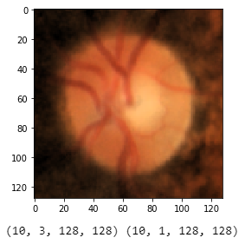

Fig 7.2.1 Digital Fundus Image

7.2.2 Segmented OD

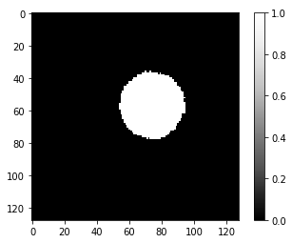

Fig 7.2.2 Segmented OD

7.2.3 Cropped ROI

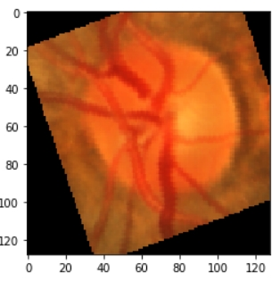

Fig 7.2.3 Cropped ROI

7.2.4 Optic Cup and Optic Disc Localization

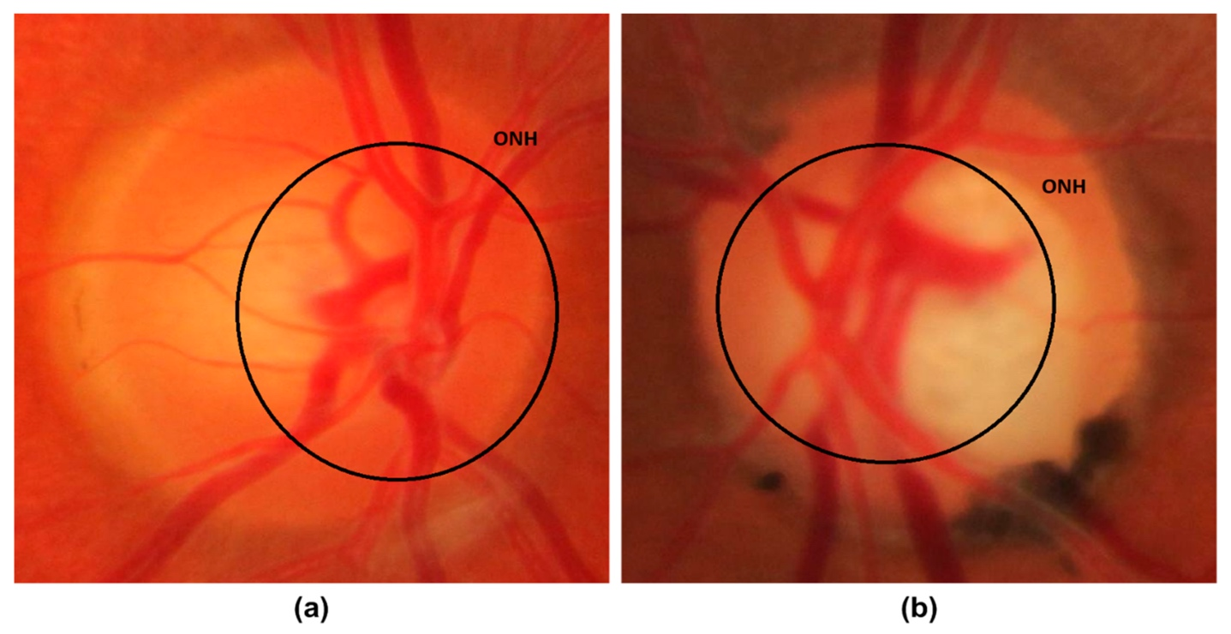

Fig 7.2.4 Optic cup and Optic Disc Localization

7.2.5 Detection of Fundus Lesions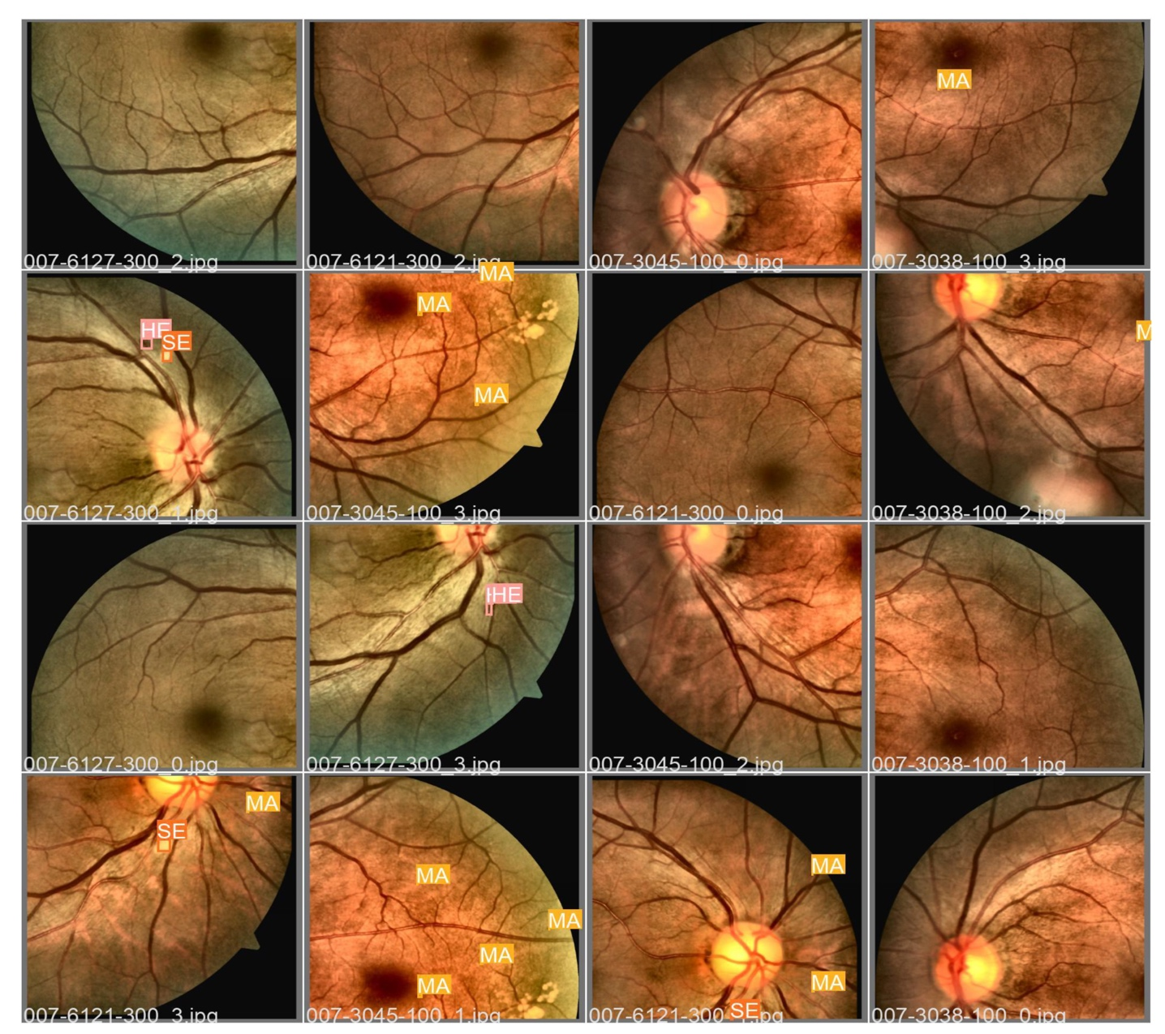

Fig 7.2.5 Detection of Fundus Lesions

**CHAPTER 8**

**SOFTWARE TESTING**

**8.1 GENERAL**

The purpose of testing is to discover errors. Testing is the process of trying to discover every conceivable fault or weakness in a work product. It provides a way to check the functionality of components, sub-assemblies, assemblies and/or a finished product It is the process of exercising software with the intent of ensuring that the Software system meets its requirements and user expectations and does not fail in an unacceptable manner. There are various types of tests. Each test type addresses a specific testing requirement.

**8.2 DEVELOPING METHODOLOGIES**

The test process is initiated by developing a comprehensive plan to test the general functionality and special features on a variety of platform combinations. Strict quality control procedures are used. The process verifies that the application meets the requirements specified in the system requirements document and is bug free. The following are the considerations used to develop the framework from developing the testing methodologies.

**8.3 Types of Testing**

**8.3.1 Unit Testing**

Unit testing involves the design of test cases that validate that the internal program logic is functioning properly, and that program input produce valid outputs. All decision branches and internal code flow should be validated. It is the testing of individual software units of the application .it is done after the completion of an individual unit before integration. This is a structural testing, that relies on knowledge of its construction and is invasive. Unit tests perform basic tests at component level and test a specific business process, application, and/or system configuration. Unit tests ensure that each unique path of a business process performs accurately to the documented specifications and contains clearly defined inputs and expected results.

**8.3.2 Functional Test**

Functional tests provide systematic demonstrations that functions tested are available as specified by the business and technical requirements, system documentation, and user manuals.

Functional testing is centered on the following items:

Valid Input : identified classes of valid input must be accepted.

Invalid Input : identified classes of invalid input must be rejected.

Functions : identified functions must be exercised.

Output : identified classes of application outputs must be exercised.

Systems/Procedures: interfacing systems or procedures must be invoked.

**8.3.3 System Test**

System testing ensures that the entire integrated software system meets requirements. It tests a configuration to ensure known and predictable results. An example of system testing is the configuration-oriented system integration test. System testing is based on process descriptions and flows, emphasizing pre-driven process links and integration points.

**8.3.4 Performance Test**

The Performance test ensures that the output be produced within the time limits, and the time taken by the system for compiling, giving response to the users and request being send to the system for to retrieve the results.

**8.3.5 Integration Testing**

Software integration testing is the incremental integration testing of two or more integrated software components on a single platform to produce failures caused by interface defects.

The task of the integration test is to check that components or software applications, e.g. components in a software system or – one step up – software applications at the company level – interact without error.

**8.3.6 Acceptance Testing**

User Acceptance Testing is a critical phase of any project and requires significant participation by the end user. It also ensures that the system meets the functional requirements.

**Acceptance Testing for Data Synchronization:**

* The Acknowledgements will be received by the Sender Node after the Packets are received by the Destination Node
* The Route add operation is done only when there is a Route request in need
* The Status of Nodes information is done automatically in the Cache Updating process

**8.3.7 Build the test plan**

Any project can be divided into units that can be further performed for detailed processing. Then a testing strategy for each of this unit is carried out. Unit testing helps to identity the possible bugs in the individual component, so the component that has bugs can be identified and can be rectified from errors.

**CHAPTER 9**

**APPLICATIONS AND FUTURE ENHANCEMENT**

**9.1 GENERAL**

This chapter discusses the current applications of the system and potential improvements that can be made to enhance its performance and scalability. It highlights how the project can be utilized in real-world scenarios and suggests directions for future work to increase its effectiveness.

**9.2 APPLICATIONS**

The system has a wide range of applications, including but not limited to:

* **Medical Diagnostics:**  
  The algorithm can be used in healthcare to analyse fundus images for detecting conditions like diabetic retinopathy, glaucoma, or other vascular abnormalities.
* **Research and Development:**  
  The system serves as a foundation for further research in medical imaging and artificial intelligence-based diagnostic tools.
* **Educational Tools:**  
  It can be utilized in academic institutions to train students and researchers in medical image analysis and machine learning techniques.
* **Integration with Healthcare Systems:**  
  The solution can be integrated with hospital management systems for automated analysis and reporting of medical images, reducing the workload of healthcare professionals.
* **Remote Diagnostics:**  
  Enables telemedicine applications by allowing doctors to analyse fundus images remotely, providing medical insights to patients in remote areas.

**9.3 FUTURE ENHANCEMENTS**

Future work concerns to obtain a bigger dataset of fundus images to make a deeper test of the algorithm. The vessels segmentation requires an improvement due to some fails in different images and residual noise after the segmentation. The use of convolutional neural networks is part of the future work to improve the classification.

**CHAPTER 10**

**CONCLUSION & REFERENCES**

**10.1 CONCLUSION**

The presence of the cup in the disc is a strong indicator of glaucoma, a method to detect glaucoma was presented here by properly detecting the location of the cup. The disc segmentation was done by thresholding, the vessel segmentation was done using edge detection, and for the cup segmentation it was presented a method that uses the vessels and the cup intensities.

**10.2 REFERENCES**

[1] Seyed-Farzad Mohammadi, Ghasem Saeedi-Anari, Cyrus Alinia, Elham Ashrafi, Ramin Daneshvar, and Alfred Sommer. Is screening for glaucoma necessary? a policy guide and analysis. Journal of ophthalmic & vision research, 9(1):3, 2014.

[2] Maya M Jeyaraman, Maya Jeyaraman, William G Hodge, Cindy Hutnik, John Costella, and Monali S Malvankar-Mehta. The effectiveness of teleglaucoma versus in-patient examination for glaucoma screening: A systematic review and meta-analysis. 2014.

[3] Rohit Varma, Paul P Lee, Ivan Goldberg, and Sameer Kotak. An assessment of the health and economic burdens of glaucoma. American journal of ophthalmology, 152(4):515–522, 2011.

[4] A. T. Broman H. A. Quigley. The number of people with glaucoma worldwide in 2010 and 2020. British Journal of Ophthalmology, 90:262—-267, 2006.

[5] J.C. Rueda, D.P. Lesmes, J. C. Parra, R. Urrea, J.J. Rey, L.A. Rodriguez, C.A. Wong, and V. Galvis. Valores de paquimetr´ıa en personas sanas y con glaucoma en una poblaci´on Colombiana. MedUNAB, 10(2):81–85, 2007.

[6] Ministerio de Salud y Protecci´on Social. Analysis de situacion de salud visual en Colombia, 2016.

[7] S. S. Kanse and D. M. Yadav. Retinal fundus image for glaucoma detection: A review and study. Journal of Intelligent Systems, 28(1):43– 56, 2017.

[8] S. Nawaldgi. Review of automated glaucoma detection techniques. In 2016 International Conference on Wireless Communications, Signal Processing and Networking (WiSPNET), pages 1435–1438, 2016.

[9] C. Anusorn, W. Kongprawechnon, T. Kondo, S. Sintuwong, and K. Tungpimolrut. Image processing techniques for glaucoma detection using the cup-to-disc ratio. Science and Technology Asia, 18(1):22–34, 2013.

[10] C. Dhumane and S.B. Patil. Automated glaucoma detection using cup to disc ratio. International Journal of Innovative Research in Science, Engineering and Technology, 4(7):5209–5216, 2015.

[11] J. Ayub, J. Ahmad, J. Muhammad, L. Aziz, S. Ayub, U. Akram, and I. Basit. Glaucoma detection through optic disc and cup segmentation using K-mean clustering. In 2016 International Conference on Computing, Electronic and Electrical Engineering (ICE Cube), pages 143–147, 2016.

[12] S.M. Nikam and C.Y. Patil. Glaucoma detection from fundus images using matlab gui. In 2017 3rd International Conference on Advances in Computing, Communication & Automation (ICACCA)(Fall), pages 1–4, 2017.

[13] Jyotiprava Dash and Nilamani Bhoi. A thresholding based technique to extract retinal blood vessels from fundus images. Future Computing and Informatics Journal, 2(2):103–109, 2017.

[14] Jose Abel De La Fuente-Arriaga, Edgardo M Felipe-River´on, and Eduardo Gardu˜no-Calder´on. Application of vascular bundle displacement in the optic disc for glaucoma detection using fundus images. Computers in biology and medicine, 47:27–35, 2014.